Of Mice and Men:

Algorithms for Evolutionary Distances between Genomes with Translocation
John D. Kececioglu, and R.Ravi
Proceedings of the 6th ACM-SIAM Symposium on Discrete Algorithms, 604-613, 1995
Abstract
Prior algorithmic work on genome rearrangement has largely focused on analysis of a single chromosome, in terms of inversions, and more recently in terms of transpositions. In this paper we take a first step towards the algorithmic study of genome rearrangement by translocation.
- Problem formulations
- Genome : a collection of chromosomes, each of which we
represent as a string. Each character in the string corresponds to a genetic marker, such as an identified gene.
- Translocation:
,  : strings where 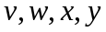 are non-empty sub strings.

I. prefix-prefix translocation : 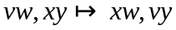
II. prefix-suffix translocation : 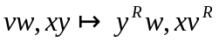, where
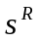 denotes the reverse of string
- Problem : we must transform one genome 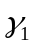 into another
genome 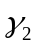 using the fewest number of translocations

I. input : ,
II. output : translocation distance, i.e. the minimum
number of translocations
- Arbitrary-length translocations
- 2-approximation algorithm
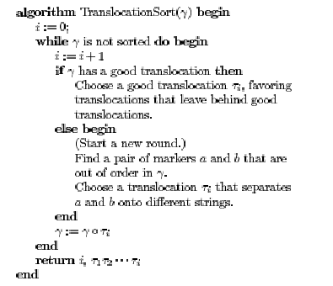

- Example

: abc : dbe
de ac
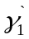 : abe
dc
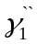 : dbe
ac
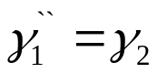

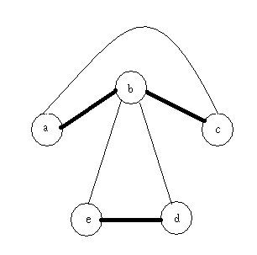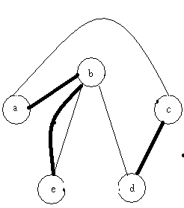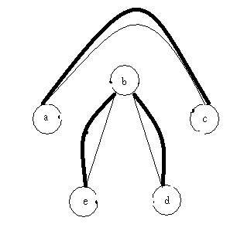

Created by : Hung-Wei Huang
Date : July 31, 2003

